Name: | SRN: | Section:
Name: | Date: | Unit 3 Assignment Exercise
PROBLEM STATEMENT-1 (for odd number SRNs):
Create and display a list of 3 patient appointments using the React framework. Each appointment should include the patient's name, reason for appointment, appointment date, and status (e.g., scheduled, completed). When a user clicks a button, the status of the selected appointment should change to "completed", and the total number of completed appointments should be recalculated and displayed. Use a style object variable for custom styling, like how you would in JavaScript. Ensure that the appointment details are read from an array of objects
OBJECTIVE
The objective of this exercise is to test the student on the front end framework React JS. It evaluates the student’s knowledge React Js components, ReactJS props and state, ReactJS Lists and Keys, React JS events
PREREQUISITE
In order to complete this exercise, the student needs to understand the fundamentals of HTML,CSS, and JavaScript

SAMPLE1:
Here's a visual representation of what the webpage will look like:
Explanation:
Sample UI Design Picture
Patient Appointments
Description:
- Header: "Patient Appointments" is prominently displayed at the top, centered.
- Appointment Cards:
  - Each card includes:
    - Patient Name: Large, bold text.
    - Reason: Description of the appointment reason.
    - Date: The date of the appointment.
    - Status: Current status of the appointment (Scheduled/Completed).
    - Button: A button to mark the appointment as completed, only visible if the appointment is scheduled.
  - Completed appointments have the name crossed out and in gray color.
- Total Completed Appointments: Displays the total number of completed appointments at the bottom, centered and bold.
SAMPLE SCREENSHOT OF OUTPUT (Just for your reference)
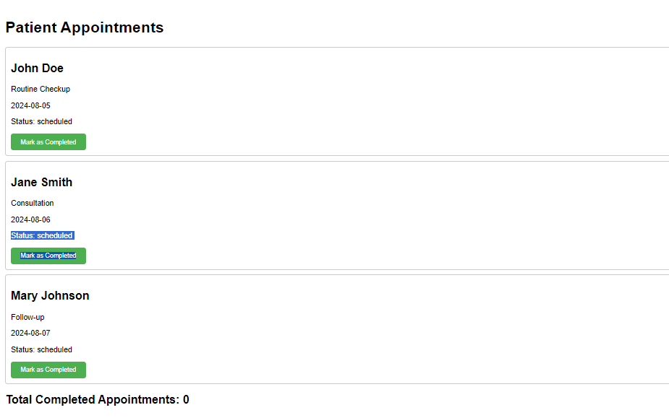

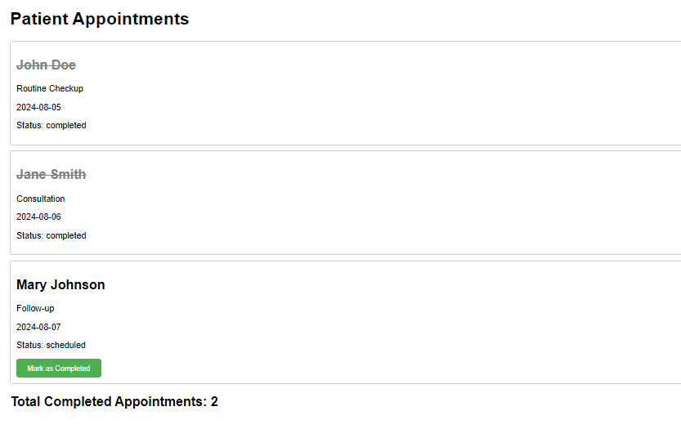

PROGRAM
SCREENSHOT OF YOUR OUTPUT

